**Name badges**

**1st Its option** Choose Size/Shape

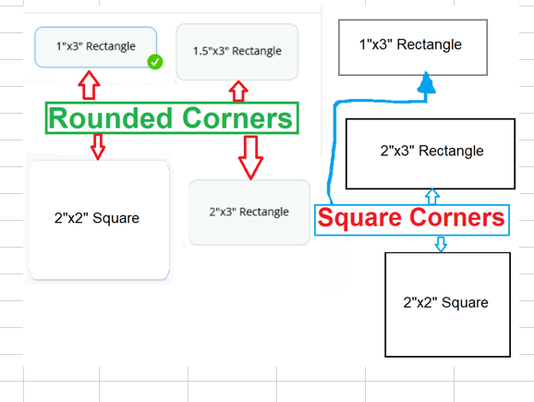

**2nd Option**  Choose Background skip the Border Options don’t need to show the Wood Grain Plastic color option

Skip the **Border Option**

**3rd Option** Fastener show all the options except for the Pocket clip ( I will get you all the mages of the fastner)

Skip the **Border Option**

Add the  **Check mark box**  to remove the logo background (which user has the option to check mark it)

**2nd Option**  Choose Background don’t need to show the Wood Grain Plastic color option Skip the **Border Option**

**3rd Option** Fastener

Skip the **Border Option**

Add the  **Check mark box**  to remove the logo background (which user has the option to check mark it)